Punchout integration on their existing site.

SOW
Customization:
1. Customize up to one (1) extension for Punchout on Your SuiteCommerce Advanced webstore to include:
a. User authentication using a mutually agreed upon standards-based authentication protocol.
b. Cart transfer back to Your third-party integlation platform (TradeCentric).
2. Customize one (1) Restlet to accept Purchase Order transfer from Your third-party integration platform (TradeCentric).
3. Customize one (1) Restlet to transfer lnvoice to vour third-party integration platform (TradeCentric).

2 and 3 to receive the purchase order and send the invoice

For Punchout2Go: use the reusable solution https://csnetsuite.custhelp.com/app/answers/answer_view/a_id/1006731/loc/en_US

Ask the customer

In red customer does it
Provide a secure domain
- Create an Employee record with access and “NSeComm | Punchout2Go” role assigned

- Give this data to TradeCentric:

Consumer key: 2d9331d34940057d790eb2175a86b701a12147b4edd74961ddc160089d8d4dc2
Consumer secret: df77d4031ab6f9cbf337bb09fe8cb84efce6bc1191e4ca4aa49de0e29e0338a0

Token key: ff76fa5605dc31e11baf9b8556b399302ccdf323b7a318d322cf5b1e099754f0
Token secret: c4a280fe891ba2014d547ecfd87427840da549e4a7f891d87af6b6a56279fb02

5. Api secret password: asuclasb1234567 (create it and give to the customer)

6.
- Invoice API (optional) Key is provided by TradeCentric if this is part of the SOW. (Optional feature, you have to check if in the sow is marked)
- Recipient Email. When converting PO to SO, some orders will need manual intervention and an email is sent to notify the admins, this is the recipient email. Un email que recibe el email de punchout. (To test you can use yours)
- Email sender is an employee record that will be used as a sender for that email. Llenar con un employee record que es el que envia el email. (To test you can use yours)
- Email template for the same email. Template is not provided by the bundle, you must create one. (Customer needs to do that, see example below):
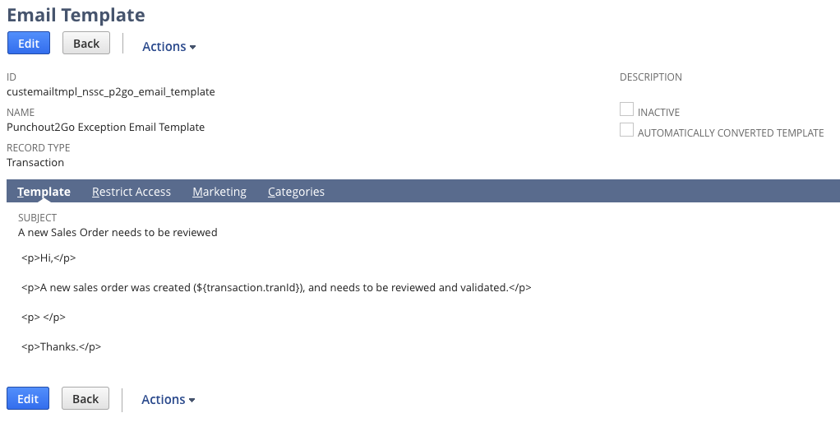
- Generic Item (optional) is used for Non-Catalog orders if it is part of the SOW (Optional). Es un item generico que sirve para las ordenes que son non-catalog (no todos los clientes lo usan, si no saben que es, dejenlo vacío porque seguramente no lo necesitan por ahora)
- Secret Key Id is the id of the secret previously created.

